**Assignment – Memory Management**

1) Setup additional swap space in the system to solve low memory issue. The swap

which you added should be available post reboot.

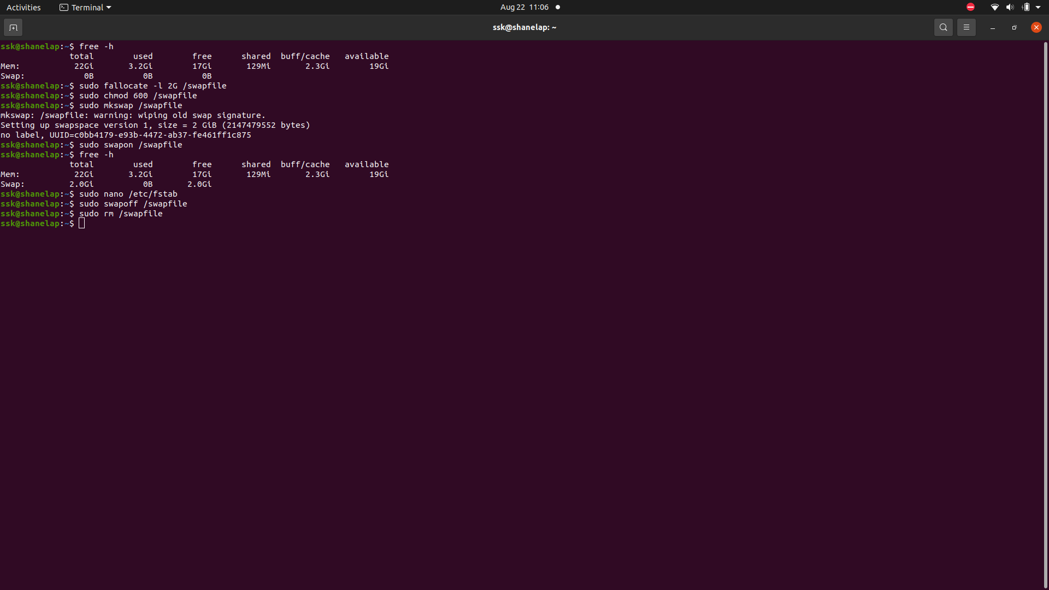

2) Find out the number of process is in run queue and blocking queue.

